INFORMATICS INSTITUTE OF TECHNOLOGY

In Collaboration with

ROBERT GORDON UNIVERSITY ABERDEEN

**Crop Disease and Pests Detection with Agricultural Community forum using Image Processing Techniques**

A Project Proposal Document by

Runisi Nikoya Samaranayake – 20221247

Damitha Udara Weerasinghe – 20210669

Seth Nimthaka Rajarathne – 20211344

Yasini Mandara Karunanayake 20221151

Supervised by

Ms. Kalhari Walawage

Submitted in partial fulfilment of the requirements for the BEng/BSc in n Artificial Intelligence And Data Science degree at the Robert Gordon University.

**October 2023**

© The copyright for this project and all its associated products resides with Informatics Institute of Technology

**Declaration**

We hereby certify that this project proposal and all the artifacts associated with it is our own work and it has not been submitted before nor is currently being submitted for any degree program.

|  |  |  |
| --- | --- | --- |
| **Student Name** | **Student ID** | **Signature** |
| Runisi Nikoya Samaranayake | 20221247 |  |
| Seth Nimthaka Rajarathne | 20211344 |  |
| Damitha Udara Weerasinghe | 20210669 |  |
| Yasini Mandara Karunanayake | 20221151 |  |

I have read the project proposal and it is in accordance with the approved university project proposal outline.

Signature of the supervisor: Date:

**ABSTRACT**

The agricultural sector faces a growing challenge in maintaining food production to meet the growing population. Mitigating the impact of pests and diseases on crop productivity is crucial. Farmers worldwide struggle with these issues, often lacking effective remedies. A mobile application has been developed to address this issue, using image processing and machine learning algorithms to propose pesticide solutions for specific diseases. The paper presents a comprehensive system for detecting disease and pests of crops, integrating technologies like ‘*’CNN for image classification’’* and an agricultural community forum for farmers to collaborate. The user-friendly system enables informed decisions and effective crop protection.

**Table Of Content**

1. INTRODUCTION 1

2. PROBLEM DOMAIN 2

3. PROBLEM DEFINITION 3

4. PROBLEM STATEMENT 3

5. RESEARCH MOTIVATION 3

6. EXISTING WORK 4

7. RESEARCH GAP 6

8. CONTRIBUTION TO THE BODY KNOWLEDGE 6

8.1. TECHNICAL CONTRIBUTION 6

8.2. DOMAIN CONTRIBUTION 6

9. RESEARCH CHALLENGES 7

10. RESEARCH QUESTIONS 7

11. RESEARCH AIM 8

12. RESEARCH OBJECTIVES 8

13. PROJECT SCOPE 9

13.1. In scope 9

13.2. Out Scope 9

14. FEATURE PROTOTYPE 10

15. RESEARCH METHODOLOGY 10

16. DEVELOPMENT METHODOLOGY 11

16.1. LIFE CYCLE MODEL 11

16.2. DESIGN METHODOLOGY 11

16.3. EVALUATION METHODOLOGY 12

17. PROJECT MANAGEMENT METHODOLOGY 13

17.1. GANTT CHART 13

17.2. DELIVARABLES, MILESTONES AND DUE OF DELIVARABLES 14

17.3. RESOURCE REQUIREMENTS 14

17.4. RISK MANAGEMENT 15

# 

# INTRODUCTION

The proposed app is a tool to support farmers, to detect the disease and pests of crops mentioned in the table below. A user friendly chatbot is included which is an online forum we facilitate knowledge sharing, collaboration, and real-time discussions among farmers, researchers, and experts and recommend remedies to them. The project's mission is to create a platform that can help farmers detect the diseases and pests for these five crops in this table and receive solutions to their problems.

|  |  |  |  |  |  |
| --- | --- | --- | --- | --- | --- |
|  | TOMATO | CASHEW | CASSAVA | MAIZE | RICE |
| CROPS | 1)Mosaic virus  2) yellow leaf curl virus  3) leaf blight  4) leaf mold  5) Septoria leaf spot  6) verticulium wilt | 1) anthracnose  2)gummosis  3) red lust | 1) bacterial blight  2) brown spot  3) mosaic | 1) leaf blight  2) leaf spot  3) steak virus | 1) bacterial leaf blight  2) brown spot  3) leaf smut |
| PESTS | 1) spider mites | 1) leaf miner | 1) green mite | 1) fall armyworm  2) grasshopper  3) leaf beetle | 1) hispa |

Table 1.1

# PROBLEM DOMAIN

Worldwide crop manufacturing is greatly threatened by diseases and pests, causing immense harm. *‘’The U.N. Food and Agriculture Organization reports that up to 40% of global crop manufacturing is decimated by these plant pests and diseases. In Sri Lanka, 30% of the population engages in the agriculture sector.’’* Every year, plant diseases alone cost over $220 billion to the global economy, while invasive insects cost no less than $70 billion. It's not just an economic issue, but also a danger to food security. Projected to be 9.7 billion strong by the year 2050, the global population faces a critical challenge in ensuring a sufficient supply of food. Therefore, the paramount significance of conquering crop diseases and pests cannot be denied.

In developing nations, agriculture takes canter stage in supporting economies worldwide as it has a direct bearing on food security, employment, and prosperity. Nevertheless, farmers are confronted with many difficulties in tending their crops such as pest invasions and diseases. Consequently, such setbacks may bring about noteworthy crop losses, ultimately impacting farmers' earnings besides affecting global food supplies.

Many farmers, especially those in rural or remote areas, may not have easy access to agronomists or timely advice on managing crop diseases and pests and crops, therefore with the advent of artificial intelligence and machine learning, there is an opportunity to develop a tool that can accurately detect plant pests and diseases. This technology can provide farmers with immediate, actionable advice, so they can protect their crops. This technology can significantly reduce crop losses, increase yields and ultimately improve farmers livelihoods.

Finally, this study is important because it uses technology to solve an agricultural problem while encouraging community cooperation. Many of these problems are serious, given the global reliance on agriculture and the widespread impact of crop diseases and pests. Therefore, conducting this research can have great benefits for farmers and communities in around the world. This research could lead to the creation of a tool that serves both individual farmers and the global community. By assisting farmers in effectively dealing with diseases and pests, we can increase yields of crops, reduce waste from food production, and ensure a more consistent supply of food.

# PROBLEM DEFINITION

This research project aims to address the important issue of disease and pest detection in crops using image processing techniques. Early control and management of diseases and pests is important in agricultural practices to improve crop growth and yield but traditional manual screening methods are often labor-intensive, time-consuming and imprecise. Farmers and agronomists face significant challenges in effectively monitoring and responding to diseases and pests, which can reduce crop quality and economic losses so there is an urgent need to develop reliable systems and it is effective enough to automatically detect and classify diseases and pests in crops.

The aim of this venture is to establish a system capable of identifying diseases and pests in crops and providing remedies for such issues. The purpose of this study is to make strides in precision agriculture and provide a useful resource for farmers and agricultural professionals to efficiently track and handle crop health. The creation of such a system is crucial in promoting higher crop production, minimizing pesticide usage, and promoting sustainability in the field of agriculture, ultimately bringing positive benefits to the industry as well as food security.

# PROBLEM STATEMENT

The overall goal is to create an efficient and accurate disease and pest detection system for crops utilizing cutting-edge technology and methodology in order to increase the production of agriculture and decrease losses in crop production.

# RESEARCH MOTIVATION

The main ambition of this research project is to develop an accurate, reliable disease and pests detection of the crops mentioned in Table 1.1 in one mobile application while providing a community forum for the farmers which is user-friendly, easily accessible to farmers where the farmers can address their concerns so farmers can safeguard their crops effectively.

The imperative requirement to secure worldwide food supplies and agricultural sustainability is the driving force behind research on disease and pest detection in crops. The demand for produce from agriculture rises together with the expansion of the worldwide countries population. But diseases and pests pose an enormous threat to food production since they can significantly reduce crop yields. We can protect our food supply, use fewer chemical pesticides, and have less of a detrimental effect on the environment by creating new, efficient technologies for rapid identification and control of these risks. Additionally, such research has the ability to provide agriculturalists with equipment and information necessary to make knowledgeable choices, ultimately resulting in more robust and effective systems of agriculture. Sri Lanka who has been in the agricultural field for many years are still relying on conventional methods, expertise, and direction from the local paddy agriculture authorities to identify disease and pests of crops. As a result, as study authors, we were driven to assist farmers in establishing such a system that would assist them in discovering the illnesses and pests in Table 1.1 while also delivering the best solutions to farmers' crop production issues as well as strategies to recover from them.

# EXISTING WORK

Although crop illness and detection of pests has made significant progress, no single technology currently exists that can sufficiently approach these problems in a comprehensive way. Nevertheless, a few studies that each concentrate on different facets of this problem have developed. It is necessary to combine and expand on these various initiatives in order to close this gap, developing a cohesive, all-encompassing approach that enables farmers to combat crop diseases and pests sustainably. We can provide unique and efficient alternatives for sustainable agriculture by merging current research and technology.

|  |  |  |  |
| --- | --- | --- | --- |
| **Citation** | **Technology / Algorithm** | **Advantages** | **Limitations** |
| ‘’(Ngugi, Abelwahab and Abo-Zahhad, 2020)’’ | *“Image Processing Technologies (IPTs) and Deep Learning Techniques.*  *CNN Model’’* | Compared to conventional approaches that depend on human expertise, this implementation can be faster and more efficient. | Not examine how well the CNN models work with various crops, regions, seasons, or disease stages. |
| ‘’(Domingues, Brandão and Ferreira, 2022)’’ | *‘’SVM*  *Random Forest*  *Artificial Neural Networks*  *Machine Learning’’* | The initiative promotes various strategies to reduce chemical and pesticide usage by farmers, thereby enhancing crop quality and yield, leading to improved precision agriculture and smart farming. | Only focuses on ML based techniques for disease and pest predictions, detection, and classification, but not consider about plant health management, such as prevention, control, and treatment. |
| ‘’(Liu and Wang, 2021)’’ | *‘’Convolutional neural networks (CNNs)’’* | Farmers can make an early diagnosis. This reduces crop losses by enabling farmers to take immediate action to stop the spread of pests or diseases. | Not provide a comprehensive analysis of different deep learning techniques for identifying pests and plant diseases across a variety of crop and environmental circumstances. |
| ‘’(Francisco et al., 2023)’’ | *‘’Convolutional neural networks (CNNs)’’* | It can help agricultural scientists and farmers in more precisely and effectively diagnosing and treating pests and plant diseases. | Not applying the algorithms and models in real-world scenarios, such as different environmental conditions, crop varieties, disease stages, or pest types. |
| ‘’(Miguel Ángel Rodríguez-García, Garcı́a-Sánchez and Valencia‐García, 2021)’’ | A natural language processing model and a rule-based model | This system aids farmers in diagnosing plant diseases, enabling them to identify crop problems' causes and take appropriate actions. | Mainly focused on only organic agriculture practices and pest control measures. |

# RESEARCH GAP

Diseases and pests pose a significant threat to agriculture across the world. According to the previously mentioned works, there have been several systems capable of identifying crop illnesses; however, there is currently no existing app that identifies both crop diseases and pests, as well as having an open forum where agriculturalists and other experts can share their ideas, and an integrated bot for instantaneous assistance with suggestions for farmers.

Taking the crops that we consider which are Tomato, cashew, cassava, maize and rice which are one of the popular crops in the world. There has not been any application that detects the diseases and pests for these crops around the world. In this proposed system the disease and pests mentioned in Table 1.1 will be identified.

# CONTRIBUTION TO THE BODY KNOWLEDGE

### TECHNICAL CONTRIBUTION

This plant disease and pest detection tool will incorporate machine learning algorithms and image processing technologies. This means that Tensor Flow is used for image classification and image training. React native will be utilized to boost user interaction with the UI, while the Android Studio tool will serve as the platform for mobile application development and testing.

### DOMAIN CONTRIBUTION

Since Sri Lankan farmers lack some level of technical literacy, developing a user – friendly and easily accessible, mobile app which would identify disease and pests of crops and recommend suitable solutions for those identified diseases and pests. This technology can provide farmers with immediate, actionable advice, so they can protect their crops.

Our mobile application will be having a community forum which is a collaborative environment where farmers, researchers, and enthusiasts can share insights and recommend remedies within the same system, and for farmers to get real time assistance with our integrated chatbot.

# RESEARCH CHALLENGES

1. Since there are 5 crops considering for the research, we would have to separately find images and details about all 5 crops and combine datasets as there were no adequate amount of resources available to find data once had to gather more information mostly from expertise.
2. Since none of the project participants are specialists in data handling and have never worked on a complicated research project before, the ambiguity in managing and cleaning datasets, as well as working with and training them, has become an obstacle in the course of the project.
3. Another problem we encountered was determining the optimal model or algorithm to employ for our project, given there are several machine learning tools available. So, by assessing and validating prior research works, we must choose the best model for this research project.
4. Given the vast number of comparable similar research projects that have already investigated various parts of the issue, it is a difficult task to establish a specific research gap.

# RESEARCH QUESTIONS

|  |  |
| --- | --- |
| RQ1 | What is the most effective algorithm for distinguishing unhealthy plant sections and pests? |
| RQ2 | How was the dataset consisting images collected in Table 1.1 ? |
| RQ3 | How would the app distinguish between genuine sickness and a condition that exhibits symptoms similar to a specific ailment? |
| RQ4 | What is the process that give the final solution for a particular disease? |

# RESEARCH AIM

This research aims to offer farmers a tool for detecting crop diseases and pests, along with a community forum for real-time assistance with our integrated bot. The chatbot will answer farmers' questions, fostering collaboration among farmers, researchers, and enthusiasts. The goal is to improve agricultural productivity, promote sustainable farming, and enhance global food security.

# RESEARCH OBJECTIVES

|  |  |  |
| --- | --- | --- |
| Research  Objectives | Explanations | Learning Outcomes |
| Problem  Identification | To detect the diseases and pests of crops in Table 1.1.   * Reading research papers and identifying the main points and improving our idea. * Identifying the best algorithm to process the images and what machine learning techniques to use train the images * Building a dataset, which consists of both diseases and pests. * Implementing a community forum for farmers. | LO1 |
| Literature Review | * RO1 : Identifying algorithms to process and analyze the image and machine learning techniques to train the image. * RO2 : Identify a technology that can facilitate an agricultural community forum. * RO3 : Identifying relevant APIs for our system. | LO1 |
| Data Gathering and Analysis  Research design | We used the Plant village dataset and collected datasets for tomato, cassava, cashew and maize and also, we used another dataset for rice and combined. Altogether five crops.  This study develops image processing algorithms to identify crop illnesses and pests while encouraging participation from the farmers in a user – friendly agricultural forum making the implementation process precise and clear. | LO2, LO3  LO2,LO3 |
| Implementation | Deploying established technology for disease and pest detection using image processing and integrating it into a one whole system. | LO2, LO3, LO4 |
| Testing  and evaluation | Putting the system through its paces using a range of unique and immediate inputs.   * Verifying and debugging the system that was developed as well as validating it. | LO2, LO3, LO4 |

# PROJECT SCOPE

### In scope

|  |  |
| --- | --- |
| **No** | **Description** |
| 1 | Identifying the disease in Table 1.1 using the uploaded image |
| 2 | Identifying the pests in Table 1.1 using the uploaded image |
| 3 | Recommending solutions according to the pests and disease mentioned in Table 1.1 |
| 4 | If farmers have a problem with their crops or pests, a community forum was built with an embedded bot to answer their inquiries. |

### Out Scope

|  |  |
| --- | --- |
| **No** | **Description** |
| 1 | Will not be able to identify all the diseases and pests of the mentioned crops only the disease mentioned in Table 1.1 will be identified |
| 2 | The user will get only a mobile app not an web application. |
| 3 | Will not do real time monitoring such as checking the crops conditions based on humidity, temperature etc…. |

# FEATURE PROTOTYPE

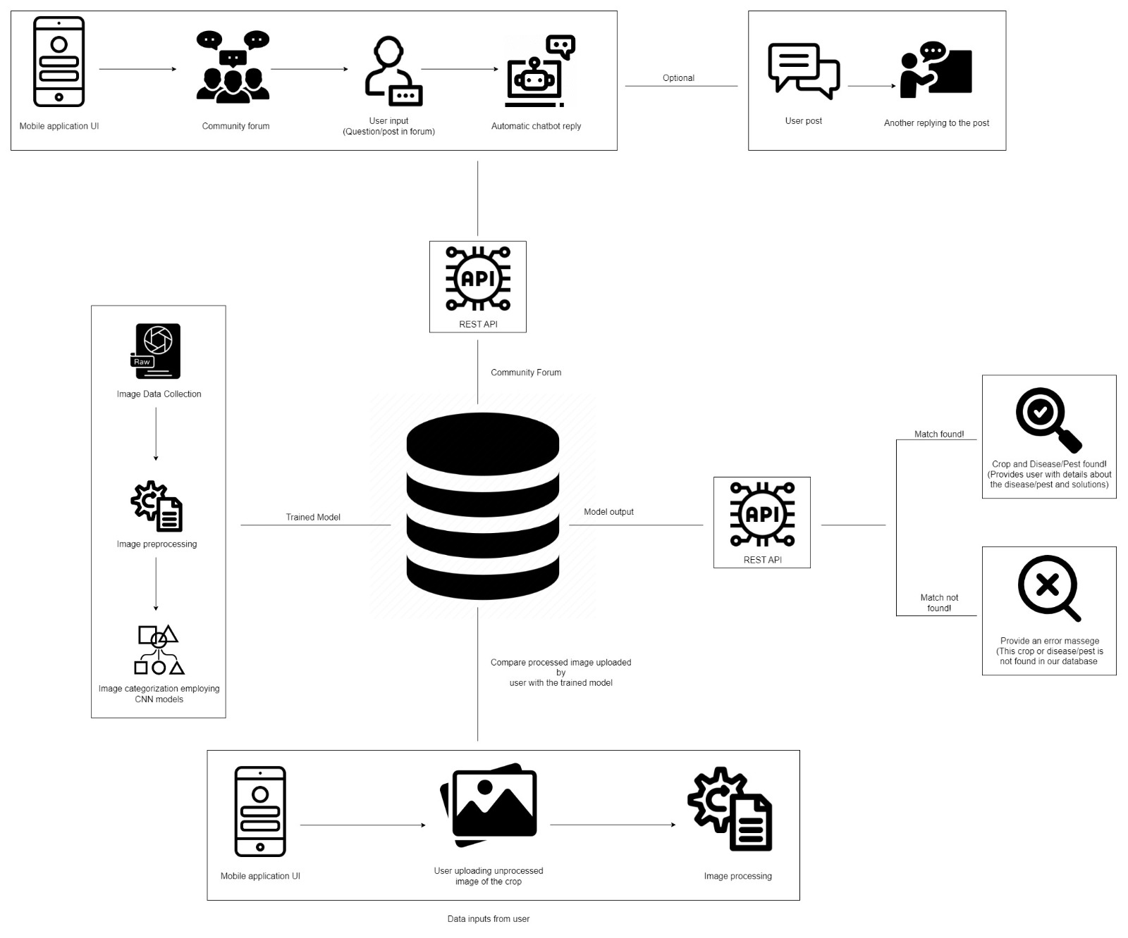

# RESEARCH METHODOLOGY

|  |  |
| --- | --- |
| Research Philosophy | The philosophy suitable for this research approach is **positivism.** It looks for causal links between variables and is based on empirical data. In this instance, obtaining and evaluating picture data will be necessary to identify illnesses and pests which resembles positivism. |
| Research Approach | Research approach is inductive because observation of diseases and pests are done first and data collected and the data is analysed and the theory is built. A pattern is recognized to achieve the final conclusion. |
| Research Strategy | Qualitive analysis as interviews are used in this research strategy and quantitative analysis for questionnaires. The combination makes it possible to comprehend the issue more thoroughly. While quantitative data can offer precise figures about the frequency and consequences of pests and crop illnesses, qualitative research can offer a more in-depth understanding of the struggles of individuals coping with these problems. This combination strategy may result in more effective illness and pest identification and management tactics in crops. |
| Research Choice | This research project will be using the research method, as the technical knowledge is gathered through interviews with research experts, farmers and students in the agricultural field and using questionnaires as well. |
| Time Zone | Cross-sectional time zone is needed since the research only runs through a certain dataset once. |

# DEVELOPMENT METHODOLOGY

### LIFE CYCLE MODEL

Crop disease and pest detection systems are constantly evolving and changing, making them the ideal fit for an agile development strategy, iterative development, close stakeholder and end-user participation. Agile enables rapid adaptability to new requirements and growing obstacles provides a better way of managing the changing requirements, given the dynamic nature of agricultural environments, disease patterns, and insect populations. Due to its adaptability, the Agile Model enables project requirements to change over time. This entails cyclical work cycles and frequent task re-evaluation.

### DESIGN METHODOLOGY

*‘’Object-Oriented Analysis and Design (OOAD)’’* is used as this design approach is appropriate for creating pest and disease detection systems for agricultural use. It makes managing complex systems easier by offering an organized method for modelling and designing software components. The *‘’OOAD* *model*’’ is adaptable and capable of dealing with progressively difficult problem areas. Various parts of the detection system, including data storage, image processing modules, and user interfaces, may be modelled as objects and their interactions. This strategy can aid in ensuring the software's maintainability, reusability, and modularity.

### EVALUATION METHODOLOGY

Evaluation metrics is a better methodology as it evaluates the effectiveness of disease and pest detection systems for crops. And by using evaluation metrics it will allow us to select the best model by comparing different models. Since inaccuracy might result in the application of the inaccurate treatment, further damaging crops, evaluation metrics are crucial for assessing the accuracy of detection systems.

# PROJECT MANAGEMENT METHODOLOGY

### GANTT CHART

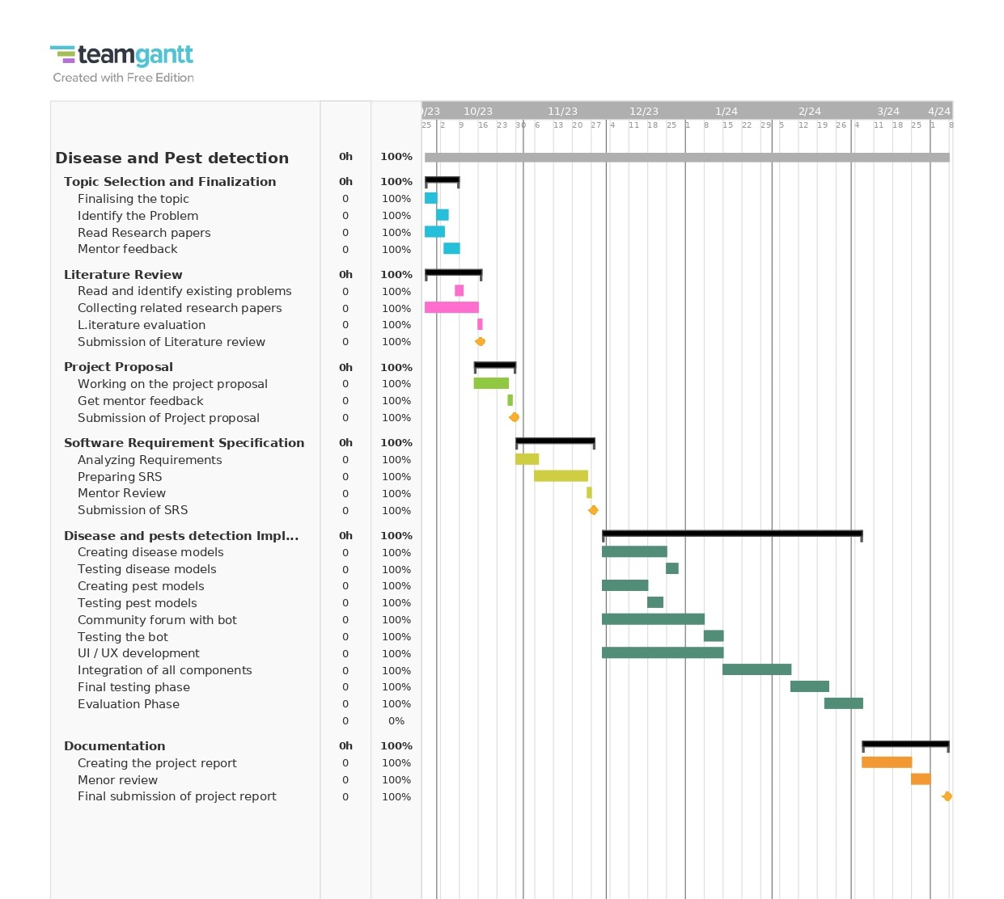

### DELIVARABLES, MILESTONES AND DUE OF DELIVARABLES

|  |  |
| --- | --- |
| **Deliverable** | **Date** |
| **SEMESTER 01** | |
| Submission of Literature review | Week 3 |
| Submission of the project proposal to the supervisor | Week 4 |
| Submission of the final project proposal | Week 5 |
| Submission of the SRS to the supervisor | Week 8 |
| Submission of the Final SRS | Week 9 |
| **SEMESTER 02** | |
| Prototype Implementation | Week 14 |
| Testing and Evaluation | Week 19 |
| Documentation and final report submission | Week 23 |

### RESOURCE REQUIREMENTS

#### Hardware Requirements

* **CPU (Intel Core i7 7th generation processor or high)** ­– To get higher performance.
* **16GB RAM or high** – To train heavy algorithms
* **Storage – 1TB SDD**

#### Software Requirements

**Python** – The main language used to create the proposed system.

**TensorFlow** – Image processing and model training.

**MySQL** – To manage database and servers

**Android Studio and React Native** – for mobile app development and testing.

**Jupyter Notebook / Visual Studio code** - For developing the software.

**Chatbot** - RASA / pandorabots

**APIs** – REST API

#### Data Requirements

Since we are focusing disease and pests detection of crops for countries around the world, we will be using Plant Village dataset which contains tomato, maize, cashew and cassava and another dataset which contains rice mentioned in Table 1.1.

* + 1. **Skills Requirements**

Programming Skills

Researching information

Planning and Scheduling

Problem Solving

Model Prototyping

Data Cleaning

### RISK MANAGEMENT

|  |  |  |  |
| --- | --- | --- | --- |
| **Risk Item** | **Severity** | **Frequency** | **Mitigation Plan** |
| Unavailability of hardware | 5 | 4 | Use cloud-based computation |
| Data loss in the project | 5 | 1 | Backing up data in a cloud-based system |
| The prediction's accuracy and preciseness | 4 | 3 | Running several tests and improving the system |
| Modifications in criteria | 5 | 4 | before implementing finding out the key points of the project |

# REFERENCES

1. Ngugi, L.C., Abelwahab, M. and Abo-Zahhad, M. (2020). ‘Recent advances in image processing techniques for automated leaf pest and disease recognition – A review. *Information Processing in Agriculture’*.
2. Liu, J. and Wang, X. (2021). ‘Plant diseases and pests' detection based on deep learning: a review. Plant Methods’, 17(1).
3. Francisco, M., Ribeiro, F., Metrôlho, J. and Dionísio, R. (2023). ‘Algorithms and Models for Automatic Detection and Classification of Diseases and Pests in Agricultural Crops: A Systematic Review’. *Applied Sciences*, [online] 13(8), p.4720.
4. Miguel Ángel Rodríguez-García, Garcı́a-SánchezF. and Valencia‐García, R. (2021). ‘Knowledge-Based System for Crop Pests and Diseases Recognition’. *Electronics*, 10(8), pp.905–905.
5. Domingues, T., Brandão, T. and Ferreira, J.C. (2022) ‘Machine Learning for Detection and Prediction of Crop Diseases and Pests: A Comprehensive Survey’, Agriculture, 12(9), pp. 1350-1376.